Optimizing Revenue Leakage and
Profitability in the Hospitality Sector

ABSTRACT

To develop a framework that helps hospitality businesses identify root causes of revenue-leakage, propose data-backed product and pricing strategies, and justify them with business logic and forecasting models(like Week-on-Week (WoW) and critical business KPIs like Revenue, RevPAR, Occupancy %, and ADR)

1. Problem Statement

In the competitive and dynamic hospitality industry, hotels and resorts often face unexplained revenue leakages, fluctuating profitability, and underutilized service offerings. These issues can stem from a variety of factors, such as inefficient pricing strategies, low performing service segments (e.g., spa, room service, event hosting), poor upselling or cross-selling, misaligned customer targeting, or seasonal demand mismanagement. Despite having access to guest behavior data, booking patterns, and service usage metrics, many mid-sized hotel chains lack a systematic approach to extract actionable insights that directly improve their revenue streams and overall business model.

2. Dataset Overview

we had given csv files of :
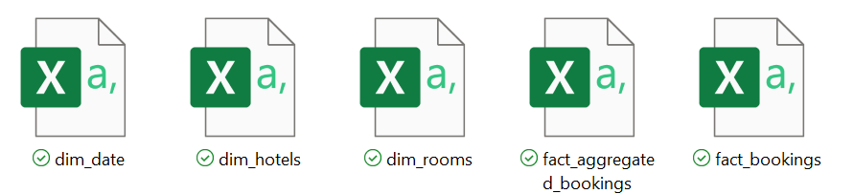
1. dim_hotels.csv – hotel metadata (property id, property name, category, city)

2. dim_date.csv – date dimension (date, mmm yy , week no, day type)

3. dim_rooms.csv – room category and details(room id, room class)

4. fact_bookings.csv – raw booking transactions

5. fact_aggregated_bookings.csv – pre-aggregated booking metrics

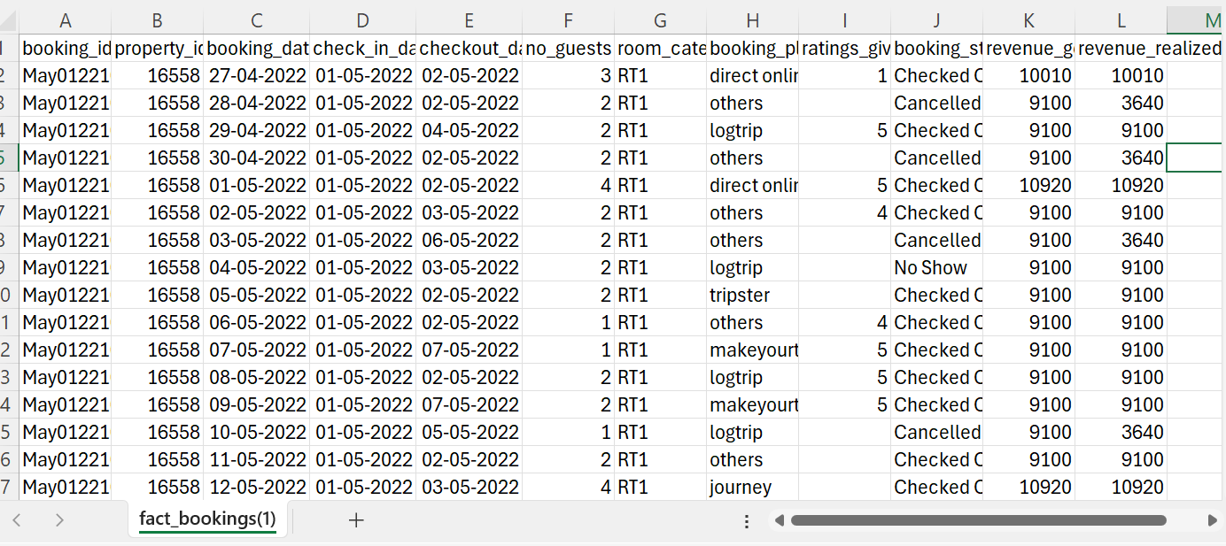
fact_booking table

3. methodology

3.1. loaded and cleaned data in jupyter notebook.

- Handling Missing Values: Almost all bookings had data present except ratings_given column, where some records had null values, which can be considered as an exception.

- Removing Duplicates: No duplicate records were found.

- Correcting Data Types: I reviewed and corrected data types and column names for dates column, dates were appropriately formatted.
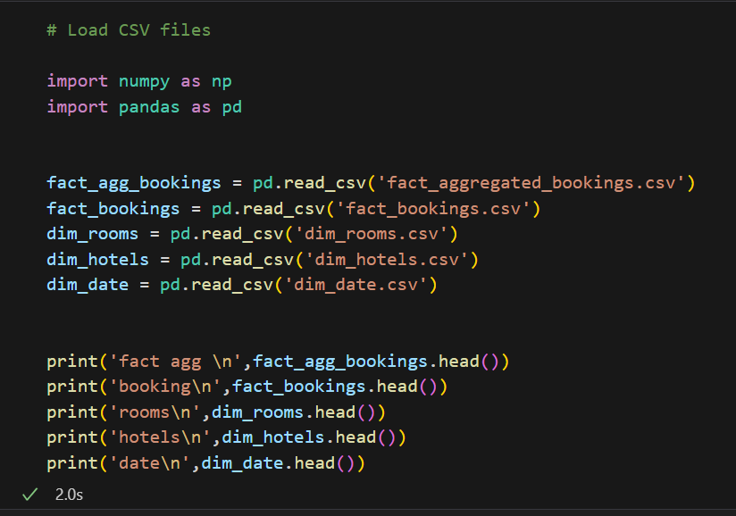
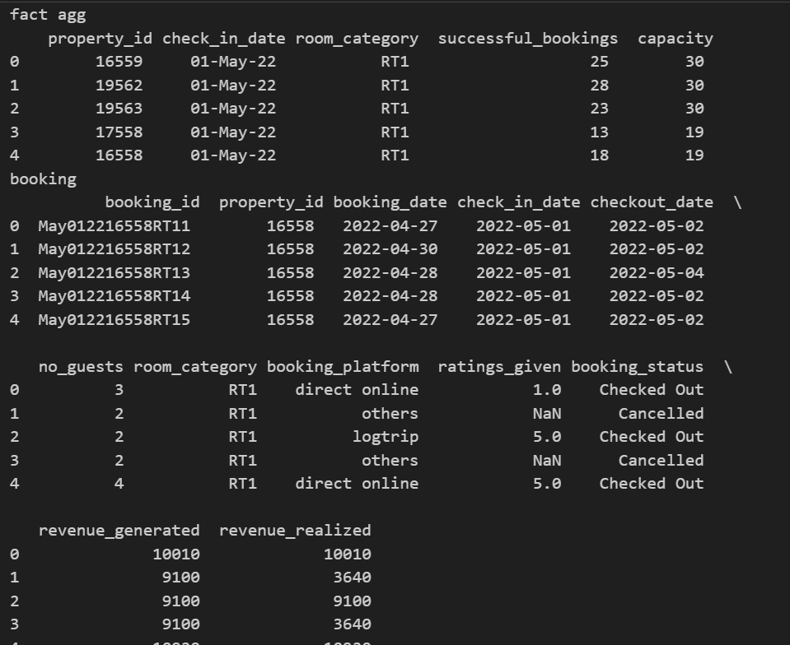
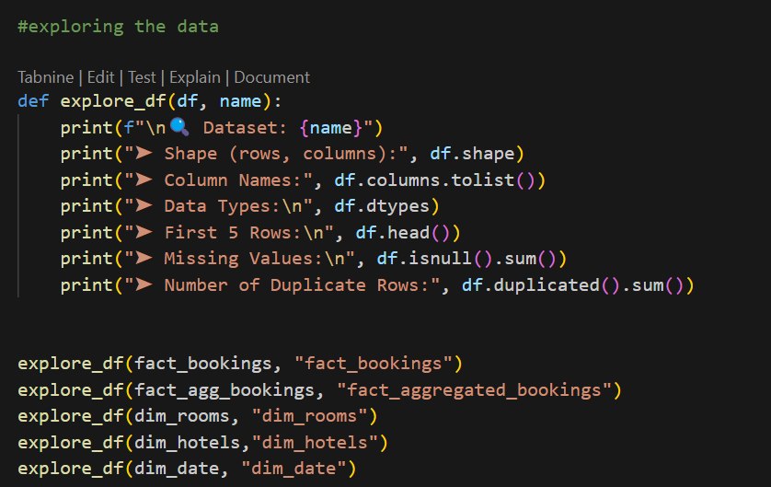
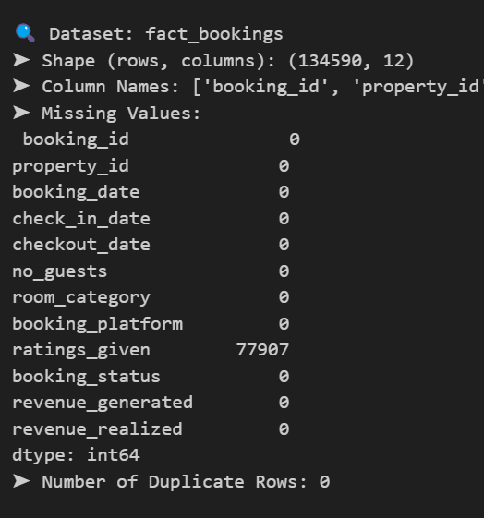
**Almost all bookings had data present except ratings_given column, where some records had null values, which can be considered as an exception.
3.2 Merged datasets

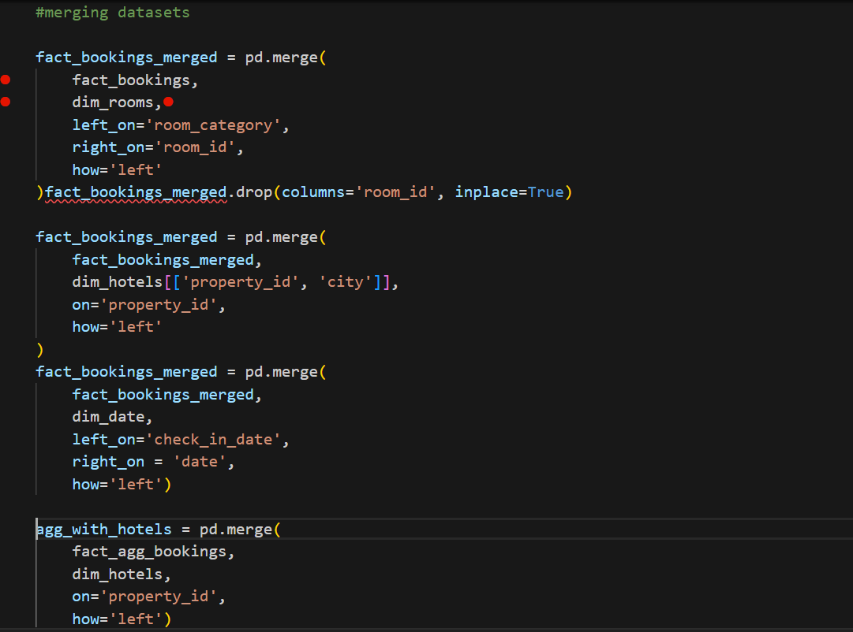

3.3 Analyzing datasets into PowerBI

1) Established relationships between tables
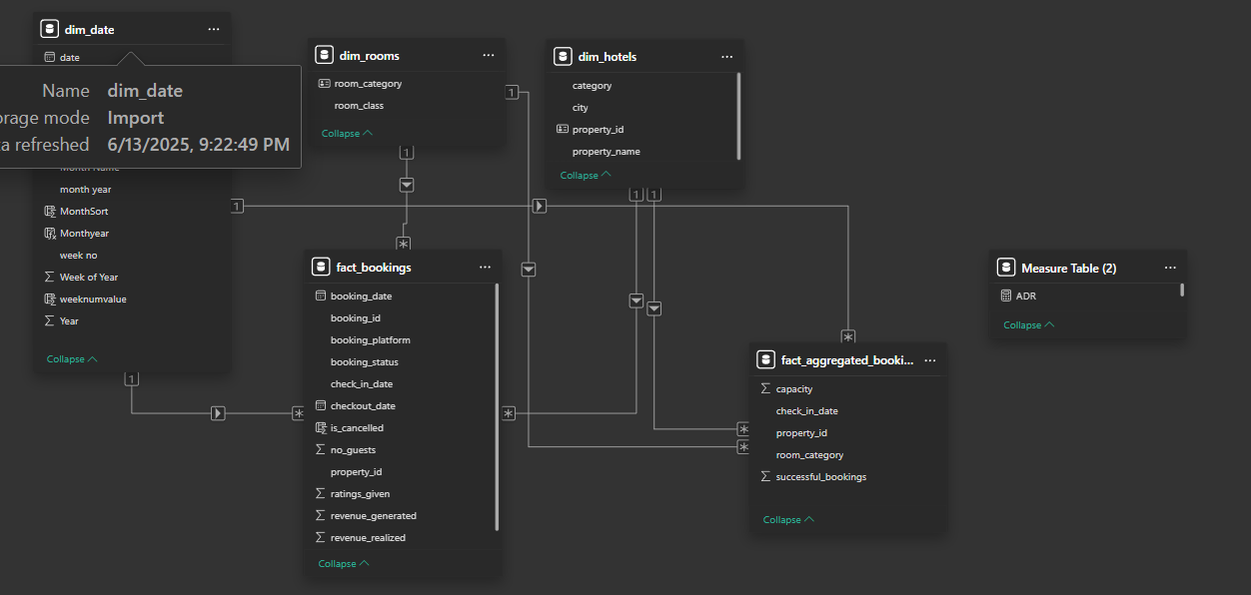

2) Date Data Type

I checked and corrected the data type of date from the given data. Dates were appropiately formated.

3) Created Calculated Columns

I created calculated columns in dim_date table to improve the data analytical capabilities. These columns include month name, month year(mm yy), month sort, week num values e.t.c. All these are created to gain more insights on the topic and improve the granurity of the data.

4) Created Measures

I created many custom measures using DAX(Data Analysis Expression) to perform different operation and create complex dashboards using those measures. Maesures i created include ADR(Average Daily Revenue),DSRN(Average room revenue per room sold), RevPAR(Revenue per available room), Booking%, Realization%, Occupation% and many more measures for further analytical insights.

3.4 Insights generation and Visualization

The Power BI generates valuable insights in dashboard in the form of KPIs, pie- chart, line chart, different slicers, gauge chart, matrix , actionable buttons and many more useful things to give our information which we need from our data which is from may 2022 to july 2022.
So, i designed dashboard in 4 pages:-

1) Home
2) Property Insights
3) Revenue
4) improvement Factors

Home

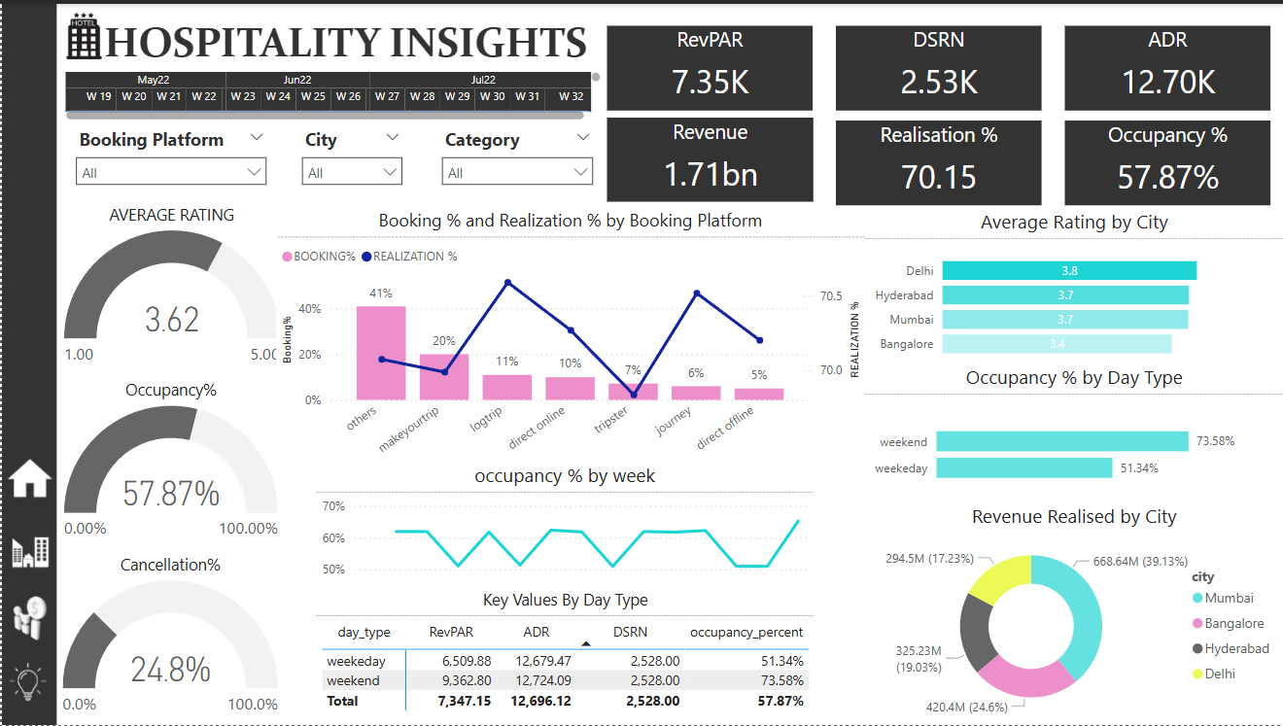

1) Logo and navigation



The navigation bar include:-


}Home

}Property Insights

}Revenue Trending

}Improvement Factors

2) Header

Header include date range from may22 to july22,which is from 19th week to 32th week and filters of booking platform, city, category.
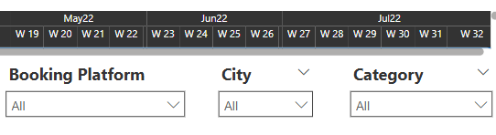

3) KPIs

